

Interação Pessoa-Máquina
Human-Computer Interaction

2020/2021

Samucar Website

Stage 5: Heuristic Evaluation



By: Lab class Nº P3

53193, Afonso Nascimento Group Nº 18
53298, Alexandre Correia
52281, Diogo Gomes Professor:
52370, Pedro Ferreira Teresa Romão

December 6, 2020

Dates

Received for evaluation  November 30 | Evaluation delivered  December 6

Heuristic Evaluation

Nº | Problem | Heuristic | Description | Severity | Solution | Screenshot
1 | Too simplistic home page | Aesthetic and Minimalist Design  & Visibility of system status | Using a blank home page leaves the user lost, if there are no workouts created already. | Cosmetic | If there are no workouts, show a message like “No workouts created”. | Fig. 1
2 | Profile cannot be edited or deleted | User control and Freedom | Once registered a user cannot change his profile infos as well as he is unable to delete the account. | Major | Add an edit button on the “Profile” section to enable the user to edit his profile. Also, when editing the profile, add a button to delete the account. | Fig. 2
3 | Workouts cannot be edited or deleted | User control and Freedom | Once a workout is created a user can change the exercises but cannot change the name or time. | Major | Enable the name and time of a workout to be edited. | Fig. 3
4 | Error message not shown | Error reporting, diagnosis and recovery | When trying to do a workout without any exercises the app doesn’t do anything. | Minor | Show an error message when the user tries to do a workout which has no exercises attributed to it. | Fig. 4.a/4.b
5 | Duplicate workouts | Error reporting, diagnosis and recovery | When creating a new workout, a user is able to create a workout with the exact same name, date and exercises as an already existing workout. | Minor | Shown an alert or error message when trying to create a new workout with the same name, date and exercises as an already existing one. | Fig. 5
6 | Adding hour to workout on calendar doesn’t work | Consistency and Standards & Error prevention | When trying to schedule a workout to a certain date the chosen date doesn’t get set. | Critical | Fix the interface so that when a user chooses a date it gets set and presented correctly. | Fig. 6.a/6.b/6.c
7 | Alphabetical order | User control and Freedom & Flexibility and Efficiency of use & Aesthetic and minimalist design | The workouts are presented in alphabetical order, and can’t be presented in any other order. | Cosmetic | Add a button to filter the list and enable the user to order the workouts by other workout attributes, such as the date. | Fig. 7
8 | Creating and doing workouts in the past | Consistency and Standards & Error prevention | When creating a workout, you are able to set its date to a date in the past. | Major | Don’t allow the users to do workouts of the past, if you want allow them to only create workout annotations. | Fig. 8
9 | Workouts reset when backing off from them | Consistency and Standards & Error prevention | If a user leaves by mistake a workout it needs to start again from the beginning. | Critical | Record the progress made by the user in each workout. | Fig. 9.a/9.b
10 | Workouts can’t be finished | Consistency and Standards & Error prevention | Similar to problem 9, if a user backs out of a multiple exercise workout, where some of the exercises have already been completed, the whole workout resets possibly making the user redo already completed exercises. | Critical | Keep track of a users’ progress on a workout and if the user accidentally backs out, the completed exercises stay marked as completed and the user can continue the workout from where it was left. | Fig. 10.a/10.b

Screenshots

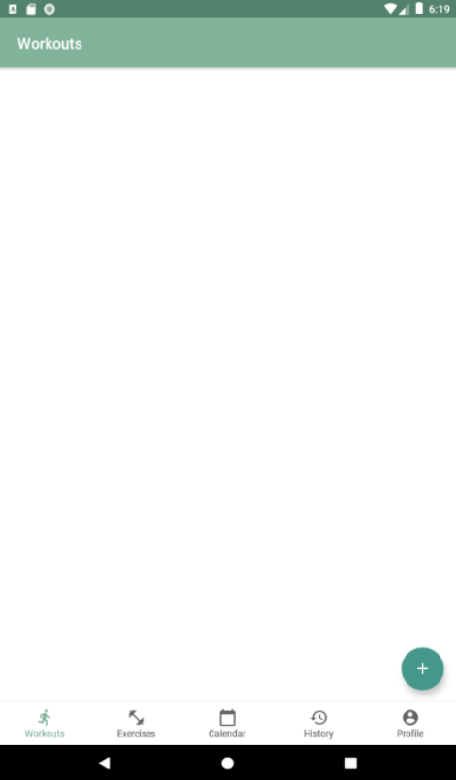
Fig. 1- Using a blank home page leaves the user lost, if there are no workouts created already.

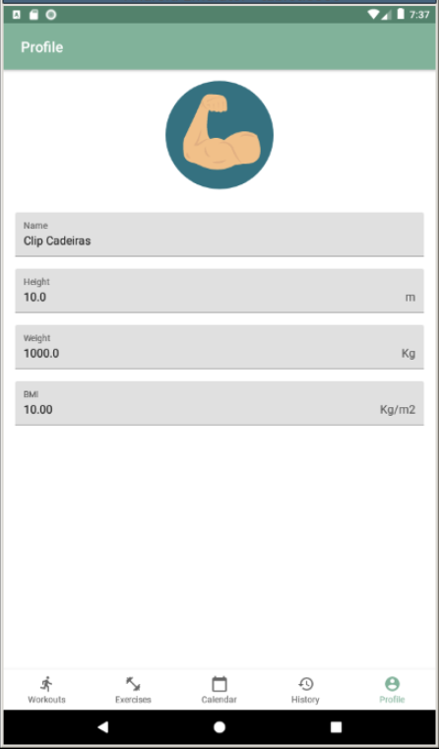
Fig. 2 - Once registered a user cannot change his profile infos as well as he is unable to delete the account.

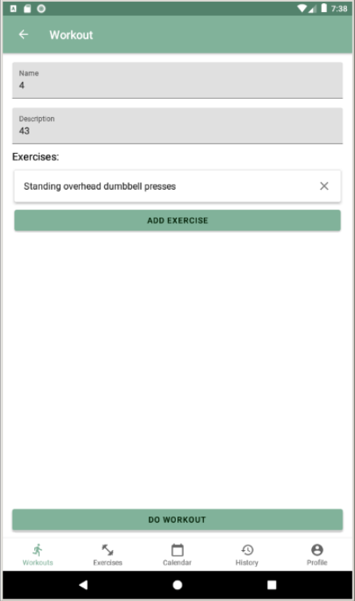
Fig. 3 - Once a workout is created a user can change the exercises but cannot change the name or time.

a)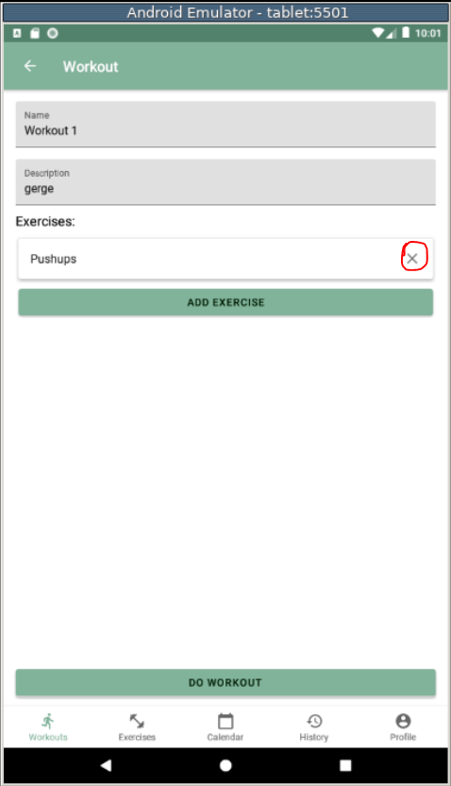 b)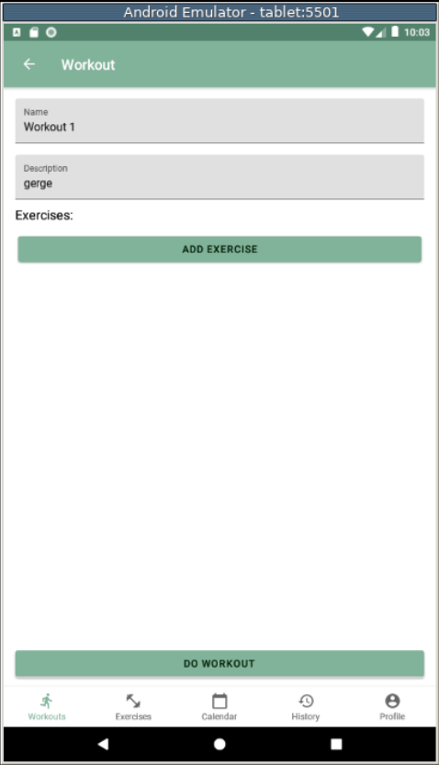
Fig. 4.a/4.b - When trying to do a workout without any exercises the app doesn’t do anything.

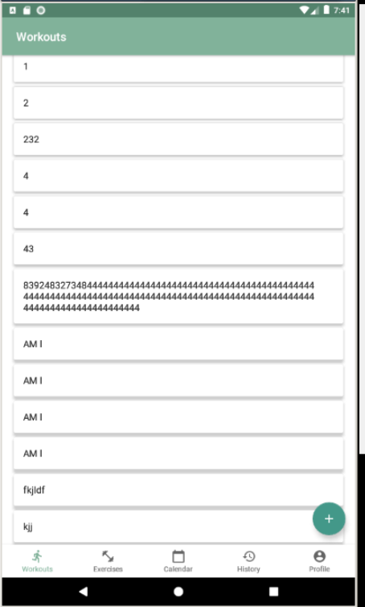
Fig. 5 - When creating a new workout, a user is able to create a workout with the exact same name, date and exercises as an already existing workout.

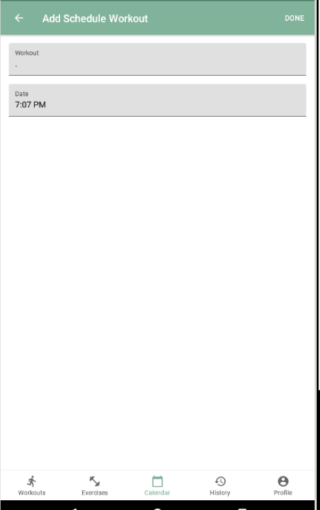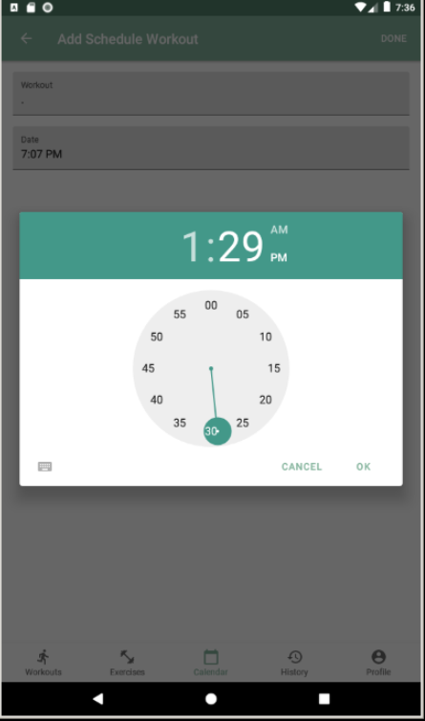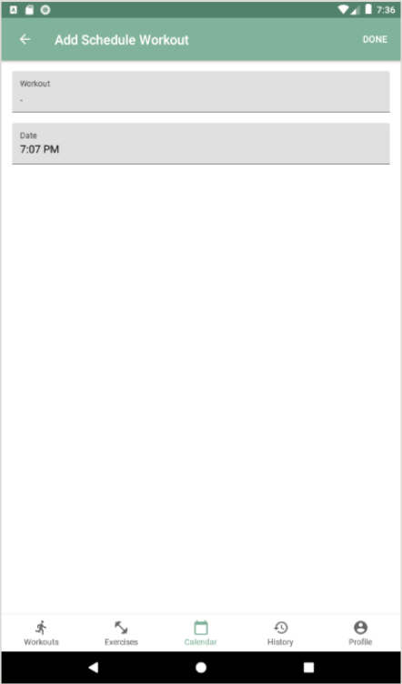
Fig. 6.a/6.b/6.c - When trying to schedule a workout to a certain date the chosen date doesn’t get set.

Fig. 7 - The workouts are presented in alphabetical order, and can’t be presented in any other order.

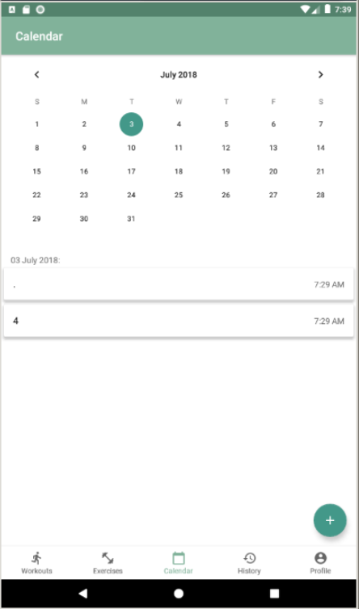
Fig. 8 - When creating a workout, you are able to set its date to a date in the past.

a)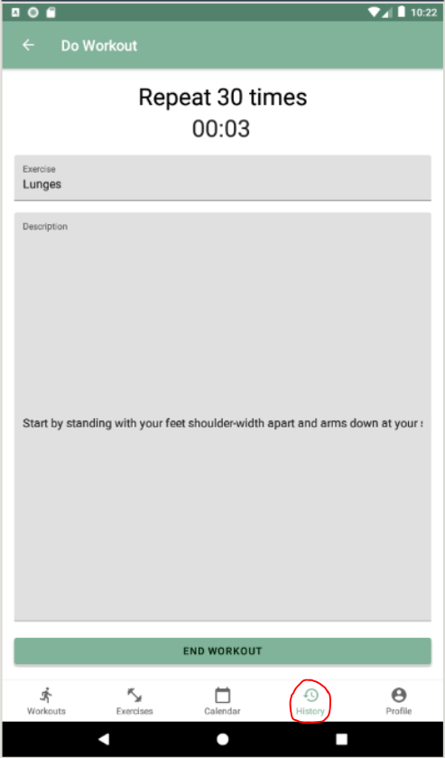 b)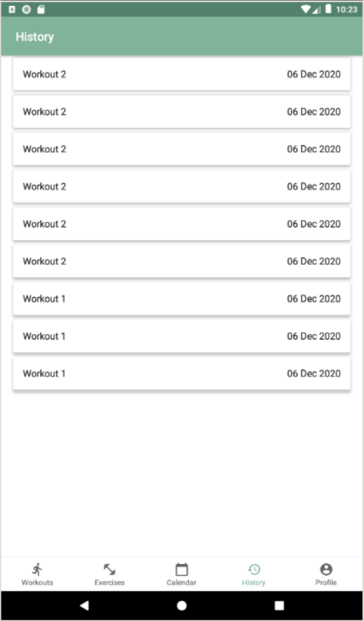
Fig. 9.a/9.b - If a user leaves by mistake a workout it needs to start again from the beginning.

a)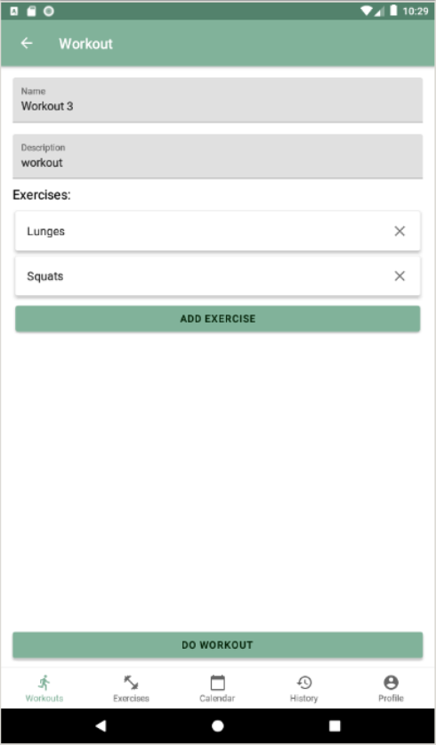 b)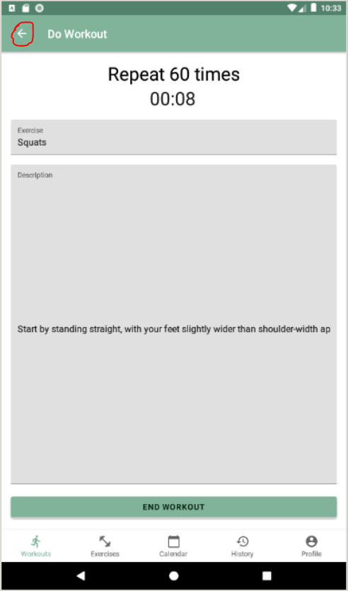
Fig. 10.a/10.b - If a user backs out of an exercise it resets the whole workout, making the user do its completed exercises again. In this example after backing out of Fig.10a the app goes to Fig.10b.

