

Interação Pessoa-Máquina
Human-Computer Interaction

2020/2021

Samucar Website

Stage 3: 1st Prototype



By: Lab class Nº P3

53193, Afonso Nascimento Group Nº 18
53298, Alexandre Correia
52281, Diogo Gomes Professor:
52370, Pedro Ferreira Teresa Romão

November 1, 2020

Sketches and storyboard

Storyboards for each scenario, including the sketches to show how your interface would look at key points of the interaction.

Scenario 1

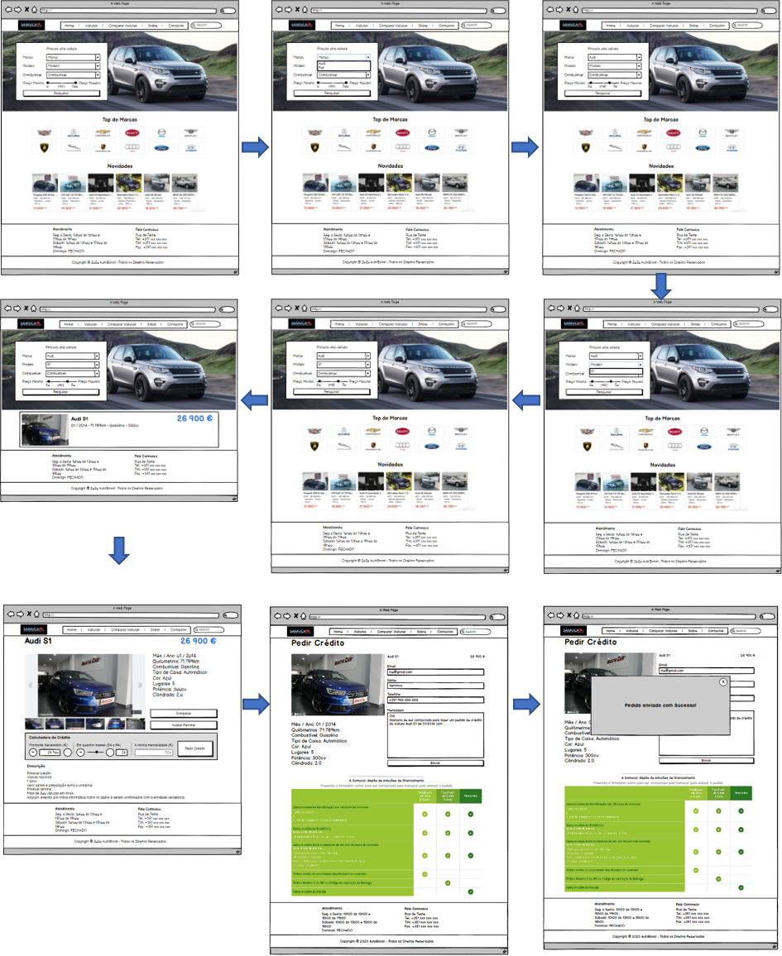

Scenario 2

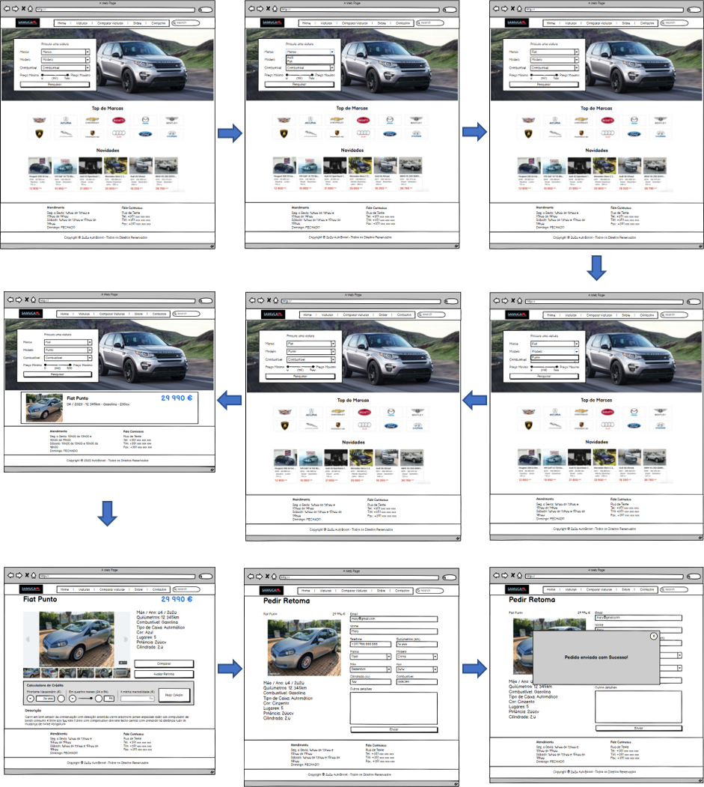

Scenario 3

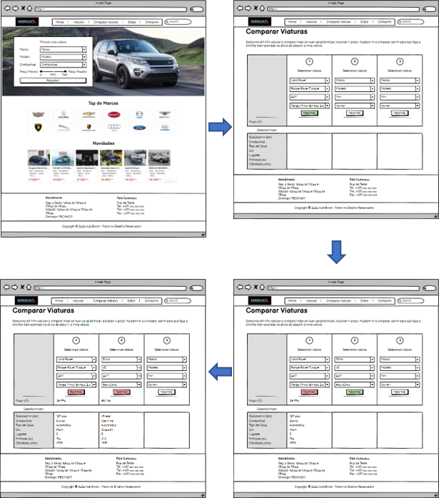

Prototype photos and link

Photos of the relevant pieces of your prototypes and the link to your prototype on Marvel.

The prototype is available at https://marvelapp.com/prototype/7ci9fj0. The most relevant pages and the interaction between them are pictured here:

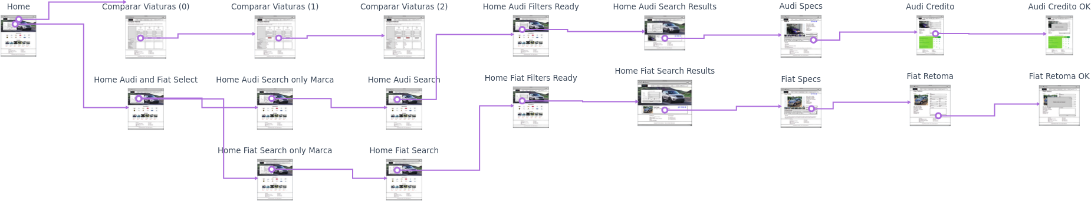

Briefing

The briefing provided to the users.

Hello! Thank you for taking the time to check our project. We, as the Autoboost team, are developing a website for a major used vehicles’ seller in Portugal - Samucar.
Nowadays people are starting to navigate throughout the web in search for their new car instead of going physically to a retailer. We think that the customers should be able to choose their new car online, in the comfort of their houses.
At samucar.pt you will find a brand new car selling experience, where you can go through all the steps necessary to choose a vehicle. We introduced 2 new features, first you can directly calculate how much you are going to pay each month if you decide to buy with a credit. You can also ask for an evaluation of your vehicle directly to the Samucar’s team, just by filling your details and sending your vehicle’s pictures.
After that, if you are still indecisive about what will be your next car, we added a functionality that lets you compare up to 3 vehicles on stock so you can be sure that you're doing a great purchase.

Scenarios

Scenario descriptions provided to the users.

Scenario 1 - Veronica needs to buy a vehicle

Veronica’s son (Alberto) is turning 18 the next month and she wants to surprise him with a new car. Veronica knows that Alberto has always loved Audi’s, especially the Audi S1, so she decides to check Samucar’s website and search for an Audi S1 with a price between 20.000€ and 50.000€.
She then chooses the cheapest one with the mandatory features that she is looking for.
After analysing the car’s specifications she decides to simulate a credit with a 24 months period and an initial amount of 10 000€ to pay for it.
She feels happy and contacts Samucar’s team (with the information: email - me@gmail.com, name - Veronica, phone - +351 966 666 666 and message - default one) to finish the details and arrange a pick up to bring the car in time for her son’s birthday.

Scenario 2 - Mary would like to retake her car by a new one

Mary’s car, an Opel Corsa, is starting to have some issues and she is willing to retake it by a new one.
She starts looking for one that fits her needs and after a short period of time she falls in love with a Fiat Punto. She fills the various infos needed to retake her car (such as: the phone - +351 966 666 666, the brand - Opel, model - Corsa, month - December, year - 2010, displacement - 100cv, fuel - Diesel, and distance driven - 10 000km as well as her contacts - email: mary@gmail.com) and submits the proposal for the Samucar team to check it and get in contact with her.

Scenario 3 - Connie is willing to buy a SUV, but she is undecided

Connie wants to buy a SUV, but she’s divided between two cars that fits her budget.
To simplify her decision she makes use of the Samucar’s vehicle comparison feature to get all the details and differences between them.
The first car (Range Rover Evoque) has better horsepower and less mileage than the second one (BMW X5), but the last one has more seats and trunk space, which she highly values because she has 4 children.
The decision is taken and she finally contacts the stand to finish the purchase of the second option.

Observation

Usability problems found during the tests and possible solutions. Describe user comments without identifying them.

Throughout the tests carried out by the users, a few observations have been made, which are listed below:

- The search for a particular car is not entirely intuitive for the majority of the users. Some of the users had difficulty understanding the usefulness of the range to select the price and the need of entering all the information in the search system.
- The majority of the users also suggested that the comparison system should have a button leading to the vehicle details page.
- According to the users the logo of the website should be a link to the home page.
- Finally, one of the users recommended that we should be able to compare the features of more than three cars.

