
Aprendizagem Automática
Ensemble Methods
Ludwig Krippahl

Ensemble Methods
Summary
■ Ensemble methods ■ Bagging and bragging ■ Boosting and stumping
1

Ensemble methods
Ensemble Methods
2
Ensemble methods
Ensemble methods
■ Combining groups of classifiers to improve classification We'll focus on two different aproaches:
■ Bootstrap aggregating : bootstrapping to train, combine predictions to reduce variance
■ Boosting : training a linear combination of weak classifiers (mainly) to reduce bias
3
Ensemble methods
Bagging
■ Bootstrap aggregating
• Use bootstrapping to generate replicas of training set
• Train model once per replica
• Aggregate the output of the hypotheses. Example: for regression, average the predictions
4
Ensemble methods
■ Example: regression
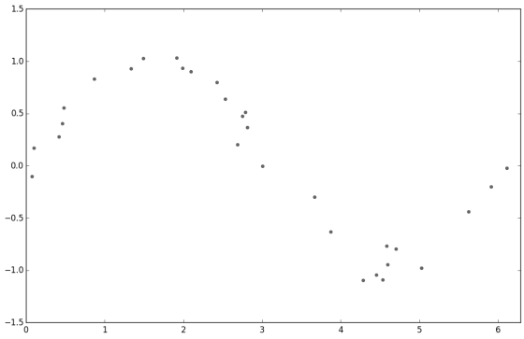5
Ensemble methods
■ Example: regression, mean
def bootstrap(samples,data):
train_sets = np.zeros((samples,data.shape[0],data.shape[1])) for sample in range(samples):
ix = np.random.randint(data.shape[0],size=data.shape[0]) train_sets[sample,:] = data[ix,:]
return train_sets
train_sets = bootstrap(replicas,data)
px = np.linspace(ax_lims[0],ax_lims[1],points)
preds = np.zeros((replicas,points))
for ix in range(replicas):
coefs = np.polyfit(train_sets[ix,:,0],
train_sets[ix,:,1],degree)
preds[ix,:] = np.polyval(coefs,px)
mean = np.mean(preds,axis=0)
6
Ensemble methods
■ Example: regression, mean
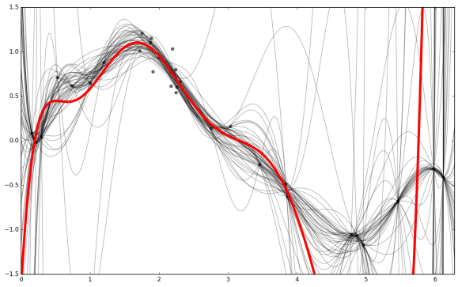7
Ensemble methods
■ Variation: median instead of mean
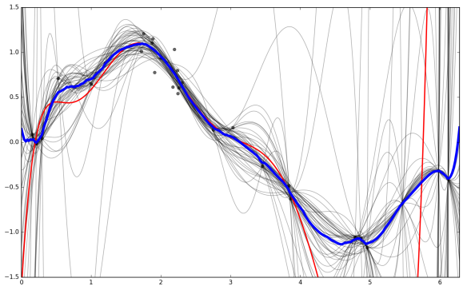8
Ensemble methods
■ Classification example: SVM
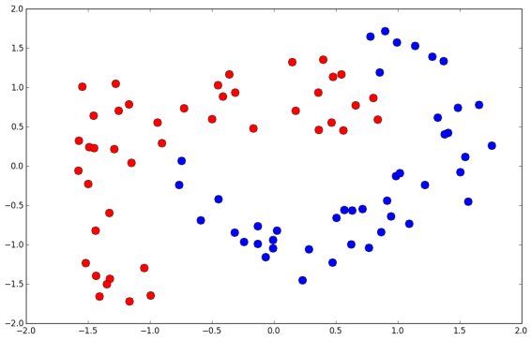9
Ensemble methods
■ Classification example: SVM (majority vote)
train_sets = bootstrap(replicas,data)
gamma = 2
C=10000
svs = []
pX,pY = np.meshgrid(pxs,pys)
pZ = np.zeros((len(pxs),len(pys)))
for ix in range(replicas):
sv = svm.SVC(kernel='rbf', gamma=gamma,C=C)
sv.fit(train_sets[ix,:,:-1],train_sets[ix,:,-1])
svs.append(sv)
preds = sv.predict(np.c_[pX.ravel(),pY.ravel()]).reshape(pZ.shape) pZ = pZ + preds
pZ = np.round(pZ/float(replicas))
10
Ensemble methods
■ 50 SVM, trained with bootstrapping
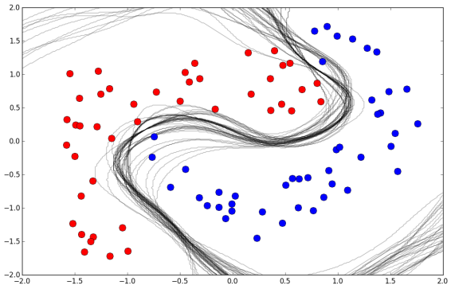11
Ensemble methods
■ Majority class of 50 SVM
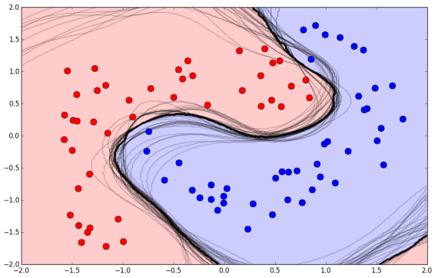12
Ensemble methods
Bagging (Bootstrap aggregating)
■ Averaging reduces variance and overfitting, increasing probability of correct classification as number of classifiers increases ^{T} T
_{k}p^{k})^{T−k}
( ) ∑ (1 − p
k=T/2+1
13
Ensemble methods
Bagging (Bootstrap aggregating)
■ Bootstrap aggregating classifiers
^{T} T
_{k}p^{k})^{T−k}
( ) ∑ (1 − p
k=T/2+1
■ This assumes classifiers are independent ■ If classifiers are correlated, this does not work so well ■ Bagging is best for unstable algorithms • (susceptible to input variations)
14
Ensemble methods
Boosting
15
Boosting
Boosting
■ Learn a linear combination of weak classifiers
■ Individual classifiers must have error rate below 0.5
■ Combination of classifiers has a lower bias and better classification power
16
Ensemble methods
AdaBoost
w_{n} = 1/N
■ Initialize sample weights:
y_{m}(x)
■ Fit classifier by minimizing weighted error
N
w^{n}_{m} y_{m} x^{n}t^{n}
J_{m} ⁼ ∑ I( ( ) ≠ )
n=1
■ Compute weighted error on training set: ^{N}w^{n}_{m} y_{m} x^{n}t^{n}
∑ I( ( ) ≠ )
ϵ_{m} =
n=1
^{N}w^{n}m
∑
n=1
17
Ensemble methods
■ Compute classifier weight:
α_{m = ln}1 − ϵ_{m}
ϵ_{m}
1
α_{m} = ln
1−ϵ_{m}
• Original (Freund and Schapire,2003):
2
ϵ_{m}
■ Compute new sample weights (and normalize): ^{n}_{m+1} w^{n}_{m} α_{m} y_{m} x^{n}t^{n}
^{w = exp}₍ ^{I( ( ) ≠ )})
■ Increases weight of misclassified points
ϵ_{m}
■ Stop when is zero or greater than 0.5
■ Output of the boosted classifier is weighted sum of classifiers: M
^{f(x) = sign} ∑ (x)
α_{m}y_{m}
m=1
18
(Decision Tree)
Decision tree algorithm
■ Split data into 2 subsets according to some feature and rule x₁ ≤ 1
• e.g.
■ Use some measure of information gain to evaluate the split
• Classification error: assuming most common class in each subset G = 1 − ∑_{c} p²c
• Gini Index:
Entropy = ∑ log _{c} p_{c} p_{c}
• Information Entropy:
■ Choose one feature and rule that optimizes information gain ■ Repeat for each subset with mixed classes
19
(Decision Tree)
Decision tree algorithm
■ Example:
20
(Decision Tree)
Decision tree algorithm
■ Example:
21
(Decision Tree)
Decision tree algorithm
■ Example:
22
Boosting
■ Stumping: AdaBoost with decision stumps (level 1 decision tree) • Choose one feature, split at one point
• Use DecisionTreeClassifier
from sklearn.tree import DecisionTreeClassifier
hyps = []
hyp_ws = []
point_ws = np.ones(data.shape[0])/float(data.shape[0])
max_hyp = 50
for ix in range(max_hyp):
stump = DecisionTreeClassifier(max_depth=1)
stump.fit(data[:,:-1], data[:,-1], sample_weight = point_ws) pred = stump.predict(data[:,:-1])
errs = (pred != data[:,-1]).astype(int)
err = np.sum(errs*point_ws)
alpha = np.log((1-err)/err)
point_ws = point_ws*np.exp(alpha*errs)
point_ws = point_ws/np.sum(point_ws)
hyps.append(stump)
hyp_ws.append(alpha)
23
Boosting
■ Stumping: AdaBoost with decision stumps (level 1 decision tree)24
Boosting
■ Stumping: AdaBoost with decision stumps (level 1 decision tree)25
Boosting
■ Stumping: AdaBoost with decision stumps (level 1 decision tree)26
Boosting
■ Stumping: AdaBoost with decision stumps (level 1 decision tree) ■ Classifying data and computing error
net_pred = np.zeros(data.shape[0])
for ix in range(len(hyps)):
pred_n = hyps[ix].predict(data[:,:-1])
preds = preds+pred_n*hyp_ws[ix]
net_pred[preds<0] = -1
net_pred[preds>=0] = 1
errors = np.sum((net_pred !=data[:,-1]).astype(int))
27
Boosting
AdaBoost, derivation
■ We can see AdaBoost as a sequential mimization of the exponential error function:
N
^{E =} ∑exp(− ( ))
t_{n} f_{m} x_{n}
n=1
f_{m}(x) m
■ Where is the weighted classification of the classifiers:
1
m
f_{m}(x) = (x)
α_{j}y_{j}
₂ ∑
j=1
f₁. . . f_{m−1}
■ All are assumed constant α_{m}y_{m}(x)
■ Minimize only for the last one,
28
Boosting
■ We can decompose the error in correctly and incorrectly classified:
N
w^{n}_{m}¹₂t_{n}α_{m}y_{m} x_{n} e^{−α}_{m}^{/2} ∑
w^{n}_{m} e^{α}_{m}/2
w^{n}m
^{E = exp}(⁻ ⁽ ⁾) ∑ = +
_{n}∑
n=1
N
−α_{m}^{/2} ∑
n∈
N
∈
w^{n}_{m} e^{α}_{m}^{/2} e^{−α}_{m}^{/2} ∑
w^{n}_{m} y_{m} x^{n}t^{n}
= e + ( − ) I( ( ) ≠ )
n=1
y_{m}
n=1
• Minimizing with respect to :
N
w^{n}_{m} y_{m} x^{n}t^{n}
J_{m} ⁼ ∑ I( ( ) ≠ )
n=1
α_{m}
• Minimizing with respect to :
1 − ϵ_{m}
N
N
w^{n}_{m} y_{m} x^{n}t^{n} ∑
α_{m} = ln = I( ( ) ≠ ) /
ϵ_{m}ϵ^{m} ∑
n=1
w^{n}m
n=1
■ AdaBoost minimizes the exponential error of the linear combination
of the base classifiers with a sequential optimization. 29
Ensemble methods
■ Two examples, to illustrate solutions to different problems. Bagging
■ Averages predictions based on different datasets (bootstrapping) ■ Good for models with low bias and high variance (overfitting) Boosting
■ Computes linear combination of weak classifiers (changing example weights)
■ Good for models with high bias and low variance (underfitting)
30
Ensemble methods
First test
31
First Test
First test
■ Lectures 1-12 (this one).
■ Next 2 sessions (lectures 13-16) not for first test. ■ Session of November 17 for questions and revisions ■ The test will be online. I will post a demo first.
■ Exam will be scored in two independent parts
• The test score for each part is guaranteed
■ Test will not include questions on Assignment 1 (unlike previous year)
32
Ensemble methods
Summary
33
Ensemble methods
Summary
■ Bagging: reduce variance by averaging
• Useful for models with large variance
• Useful for unstable models, otherwise there is too much correlation ■ Boosting: reduce bias by linear combination of classifiers • Useful for combining weak classifiers (large bias)
• Note: must be able to weigh samples
Further reading
■ Alpaydin, Sections 17.6, 17.7
■ Marsland, Chapter 7
■ Bishop, Sections 14.2, 14.3
34

